Hardening Lab

Ryan Coon

CYB-515

Dr. Edward Marchewka

October 2, 2024

Part 1:

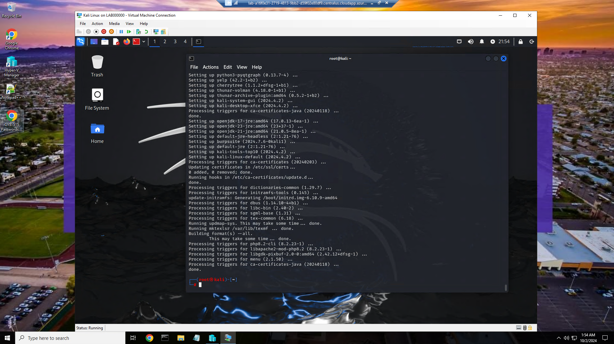

Here on our Kali Linux VB, we updated and fully upgraded the Kali system. This update and upgrade took about 30 minutes from start to finish.

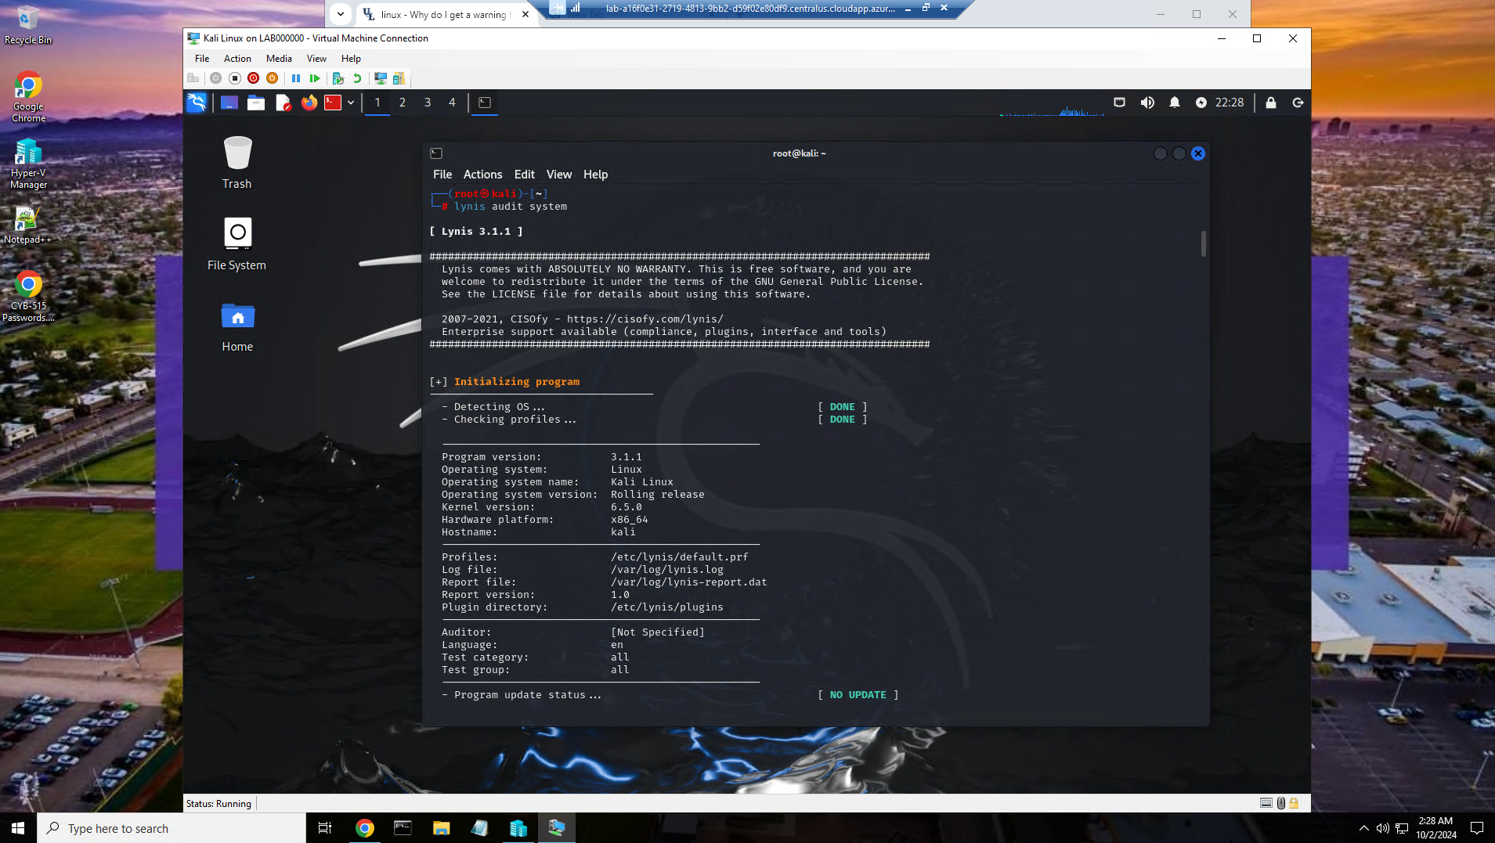

Here you can see that we started the Lynis system audit by running the command lynis audit system.

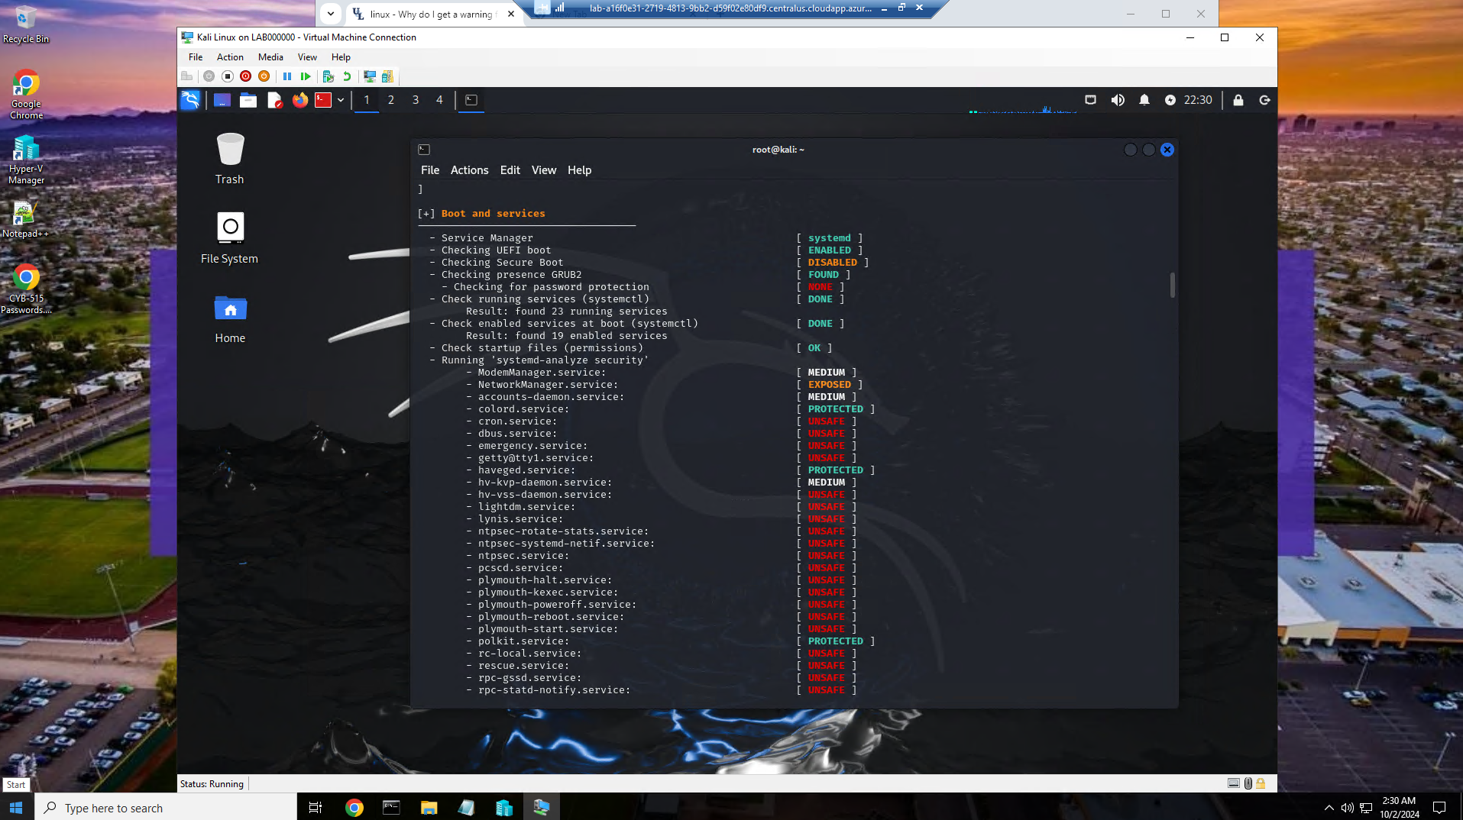

Here is a screenshot of the scan running. You can see the items that are marked protected, unsafe, medium, and exposed.

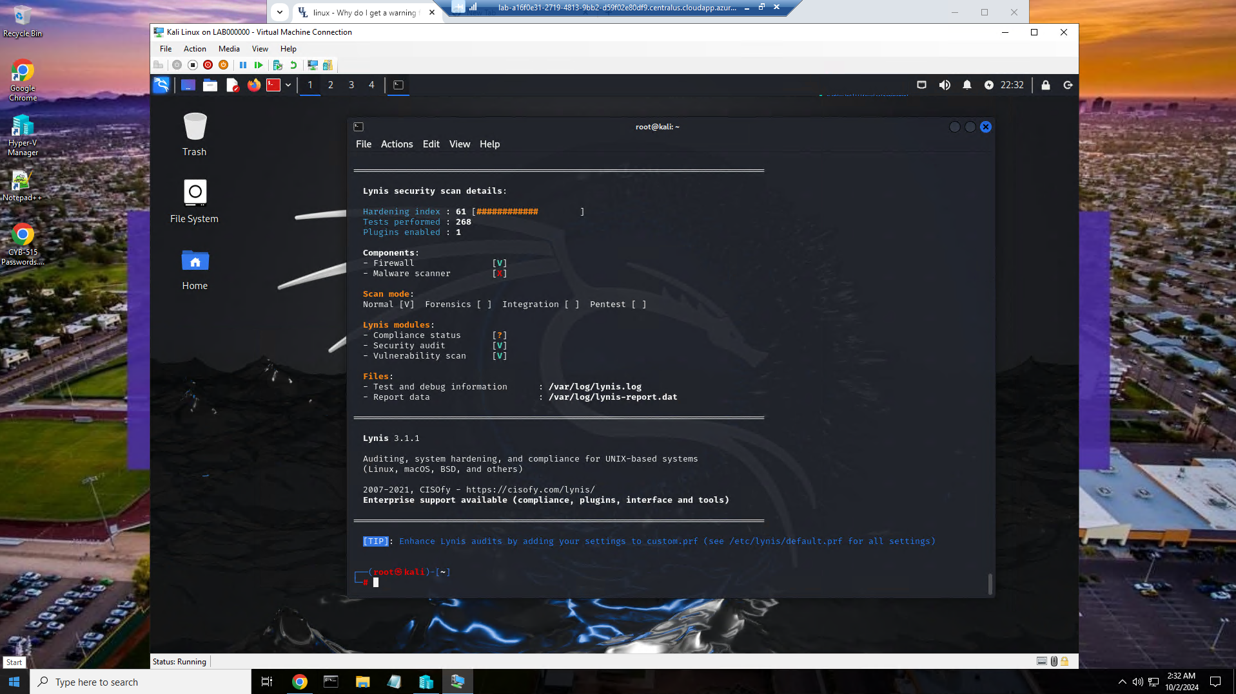

Here is the end of the audit with the scan details. Here you will find what has been tested and the status of the security.

Part 2:

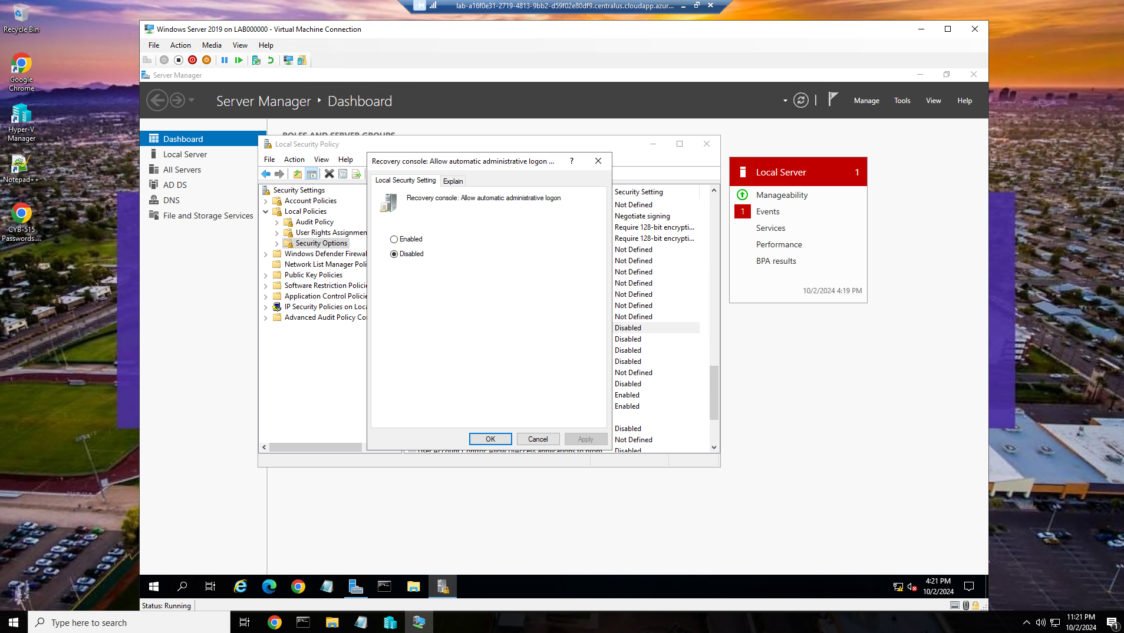

Here you can see logged in as administrator using the server manager, I disabled automatic administrative logon in the recovery console.

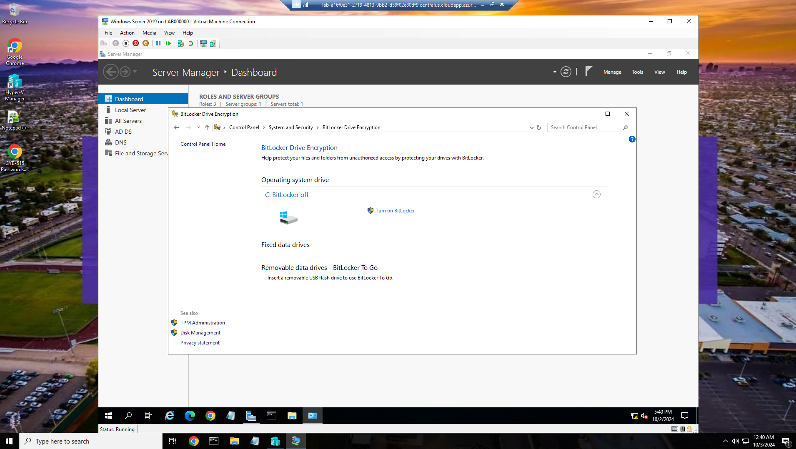

Bitlocker was installed successfully to the server.

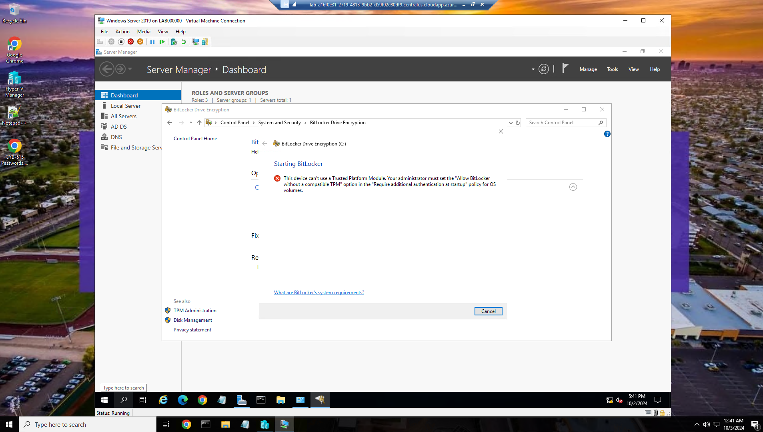

Bitlocker will not turn on due to TPM is turned off.

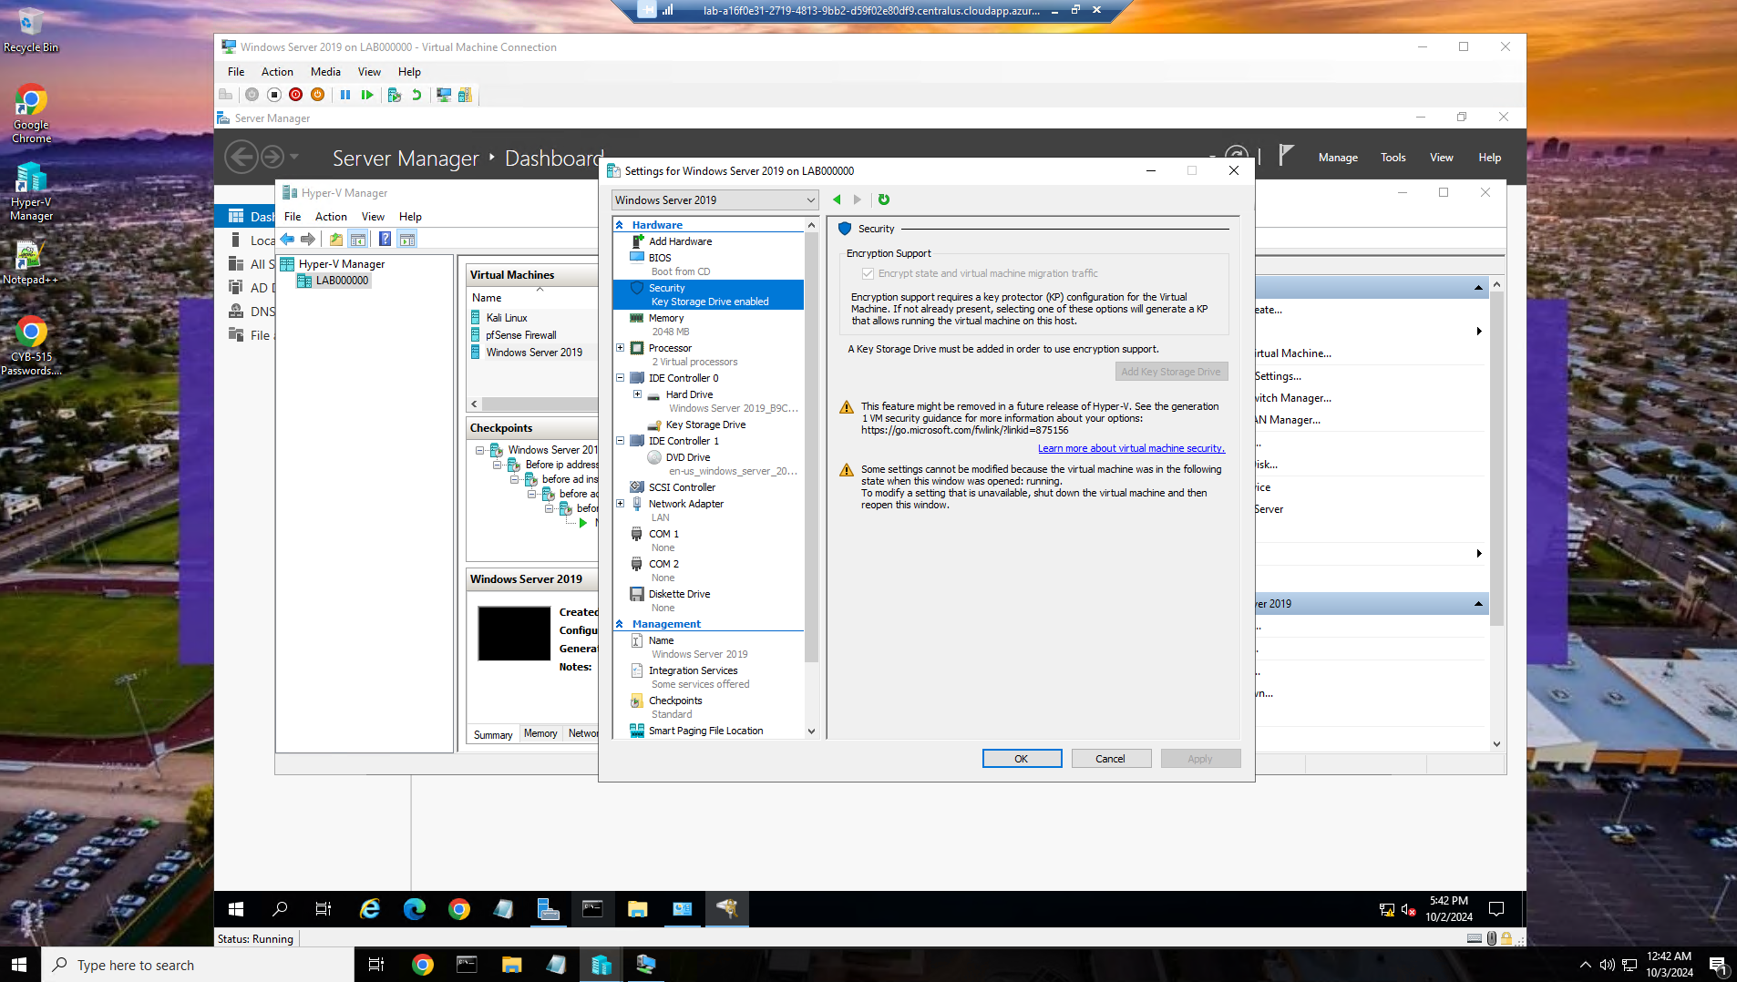

However, the version of windows/Hyper V does not have an option to turn on or allow TPM.

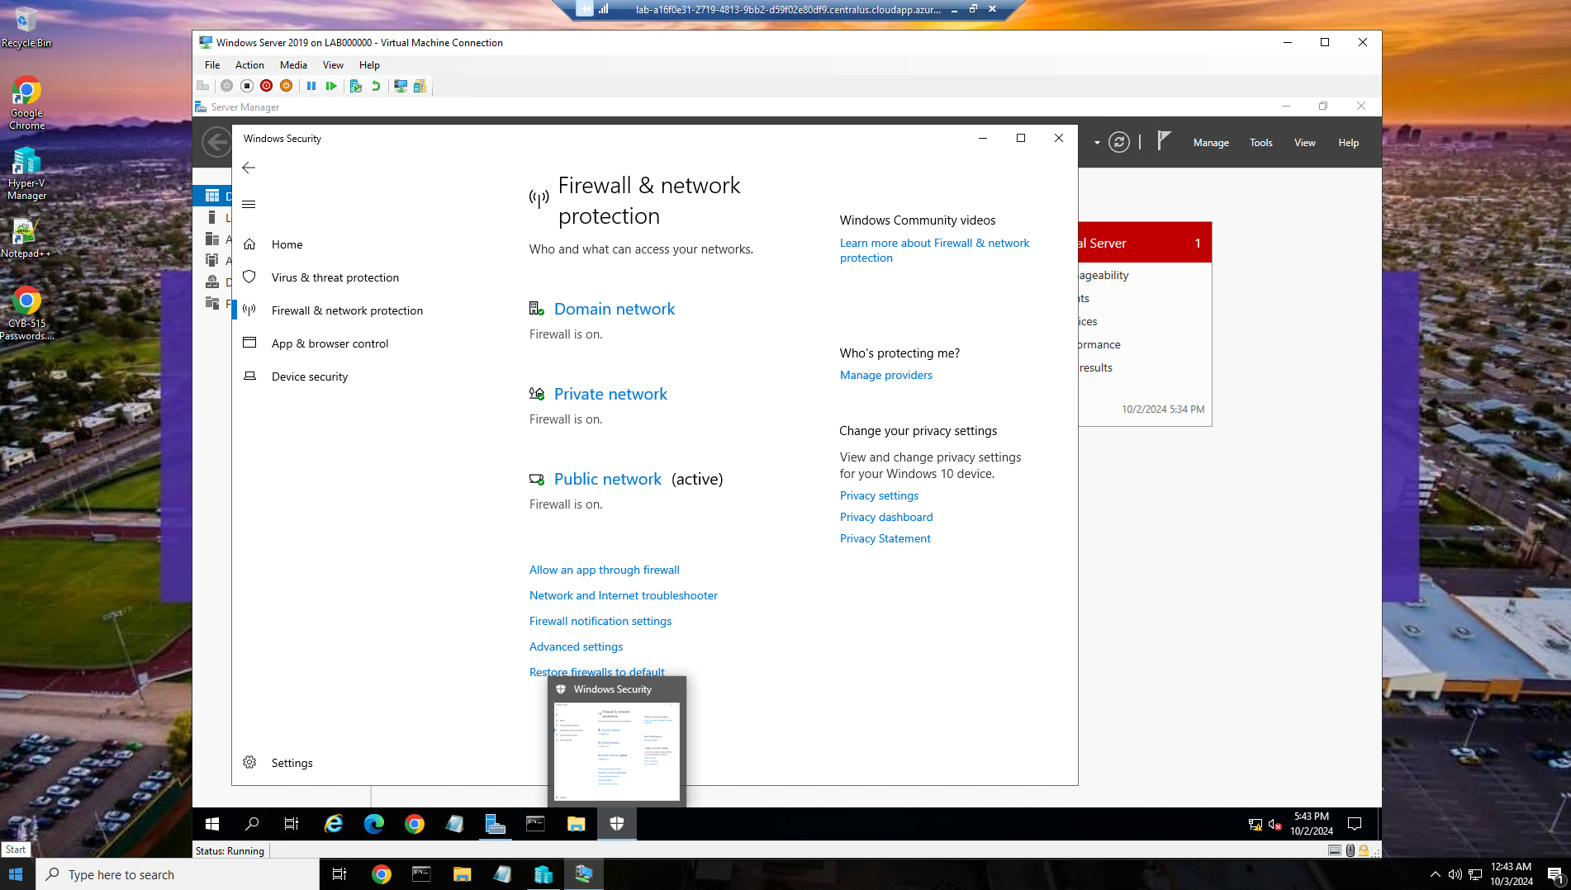

Windows firewall is enabled in all three networks(Domain, Private, and Public)

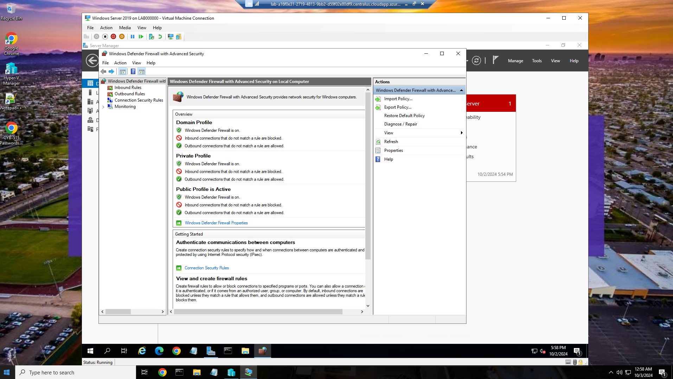

All inbound traffic on all three networks are blocked by default.

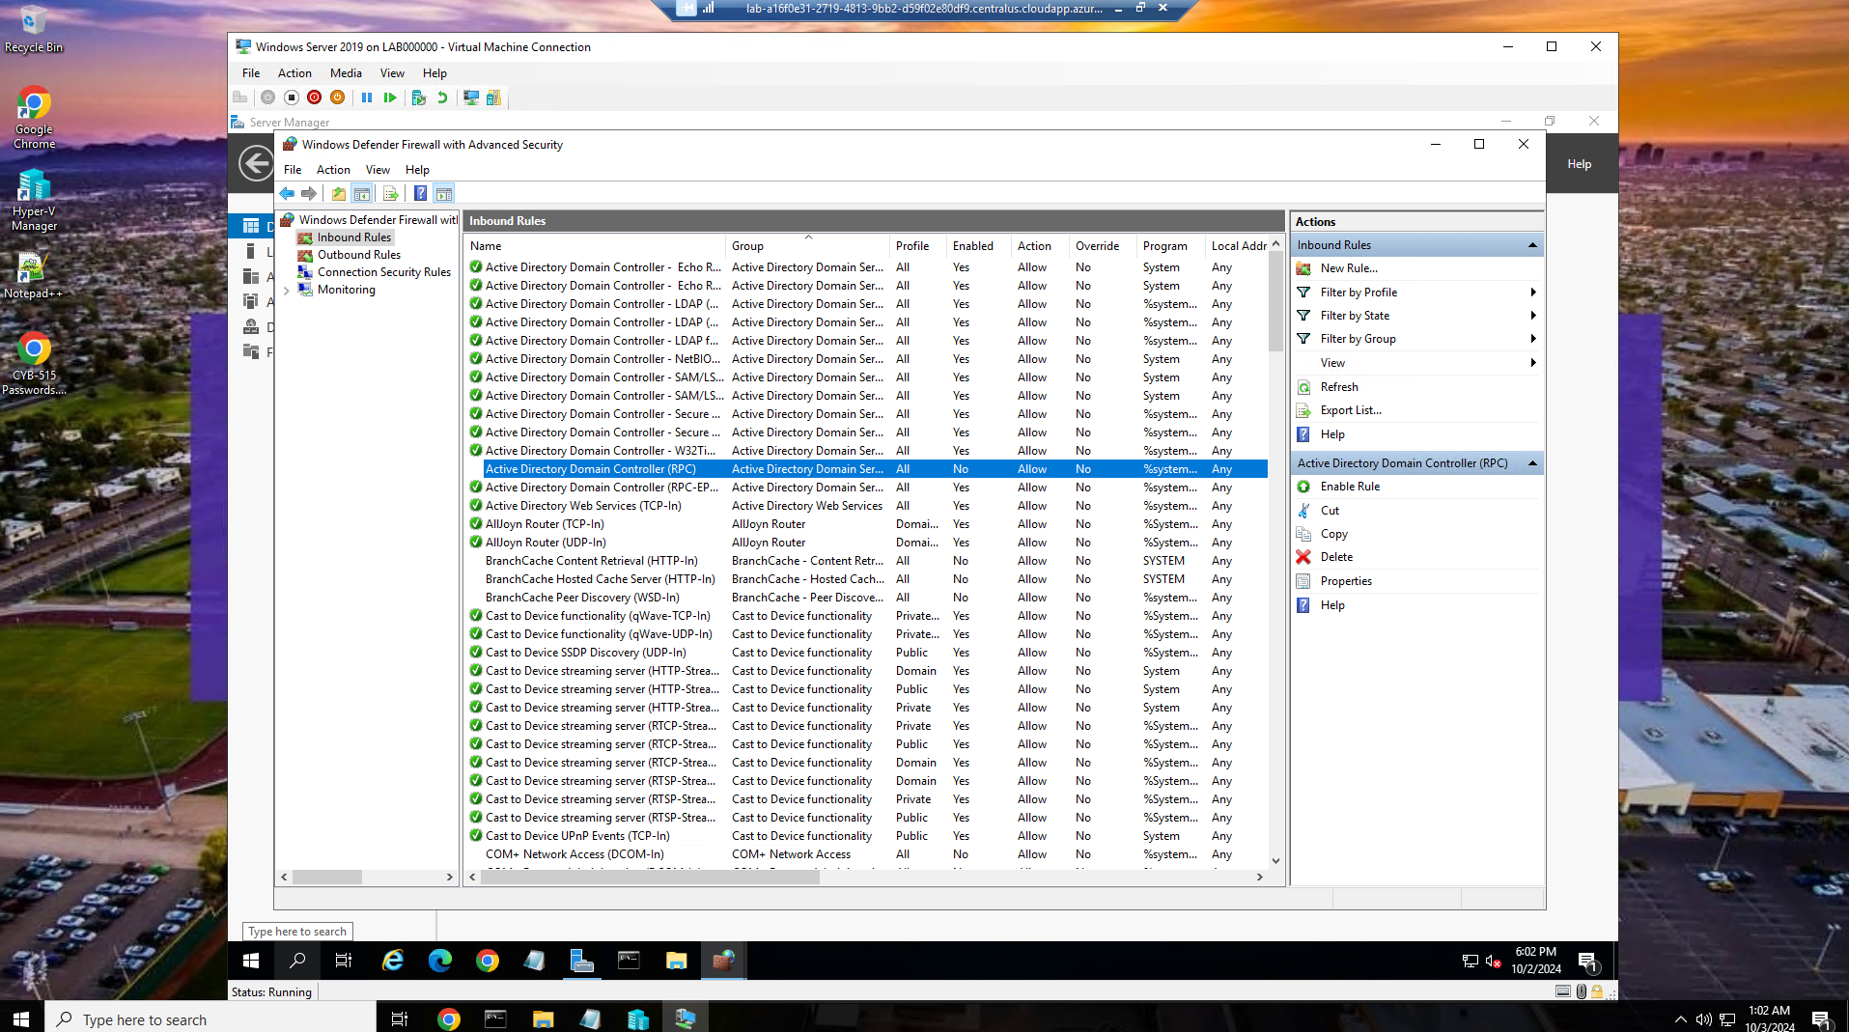

Specific ports selected where we can either allow or reject within our system’s firewall settings.

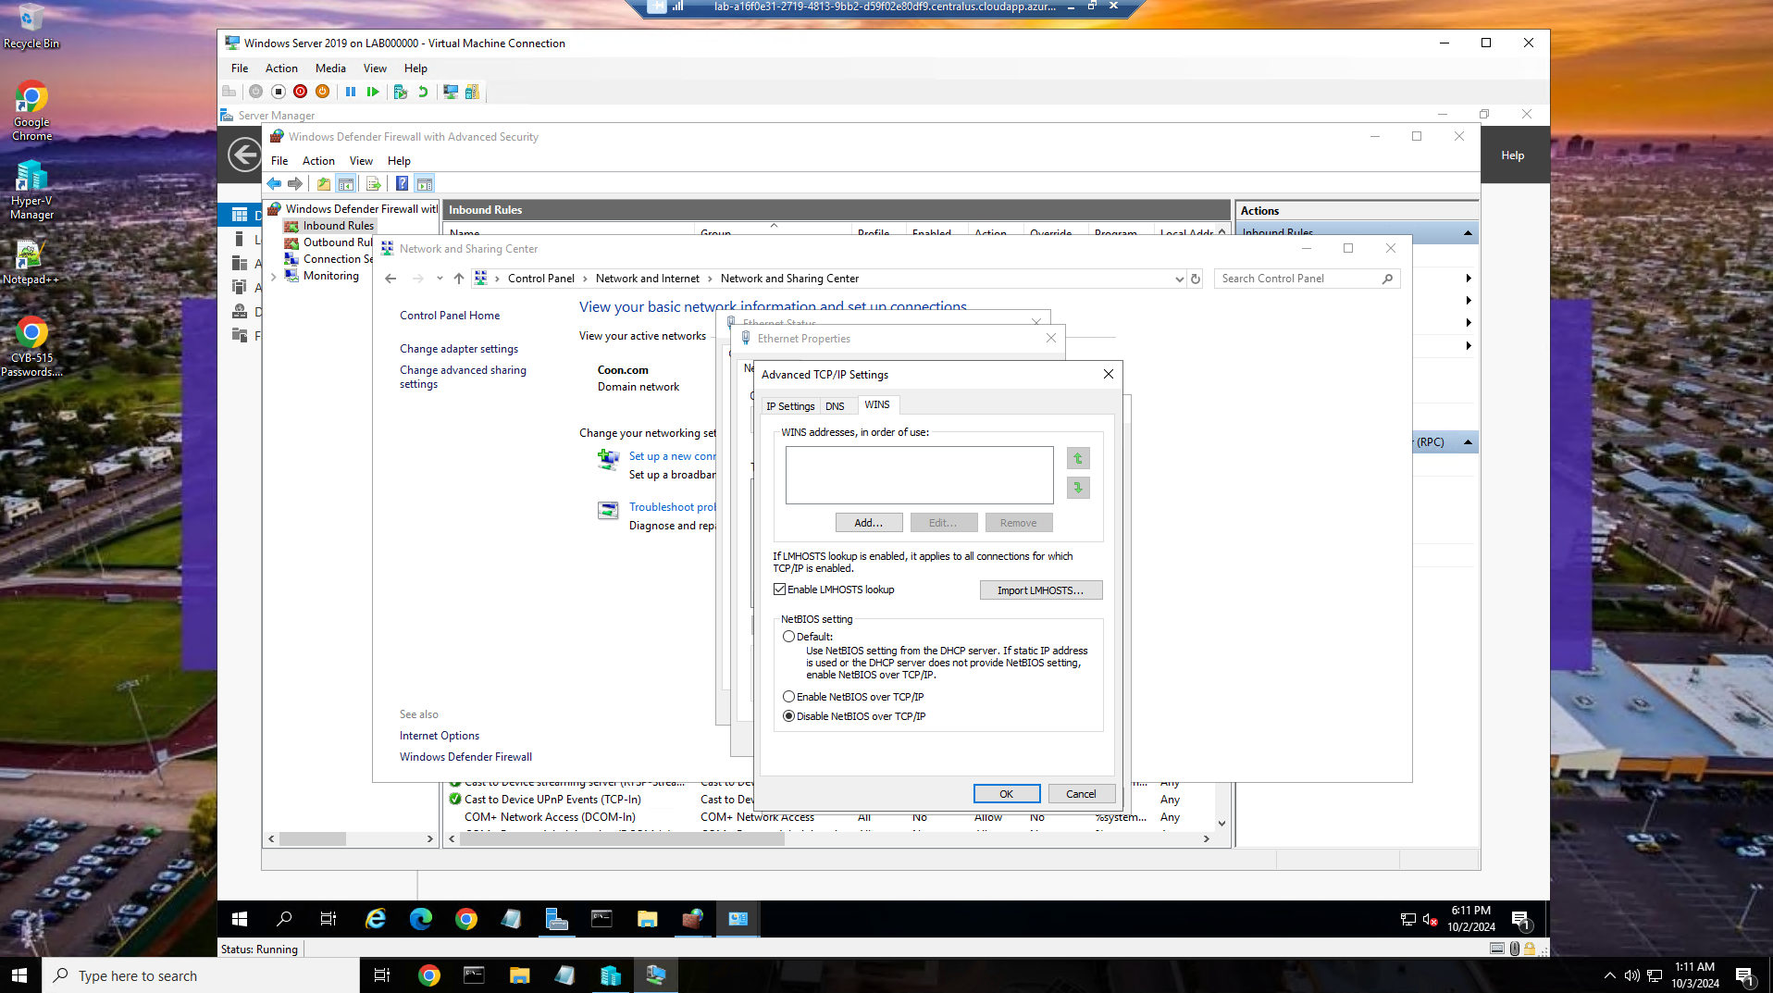

Disabled the NetBios over TCP/IP.

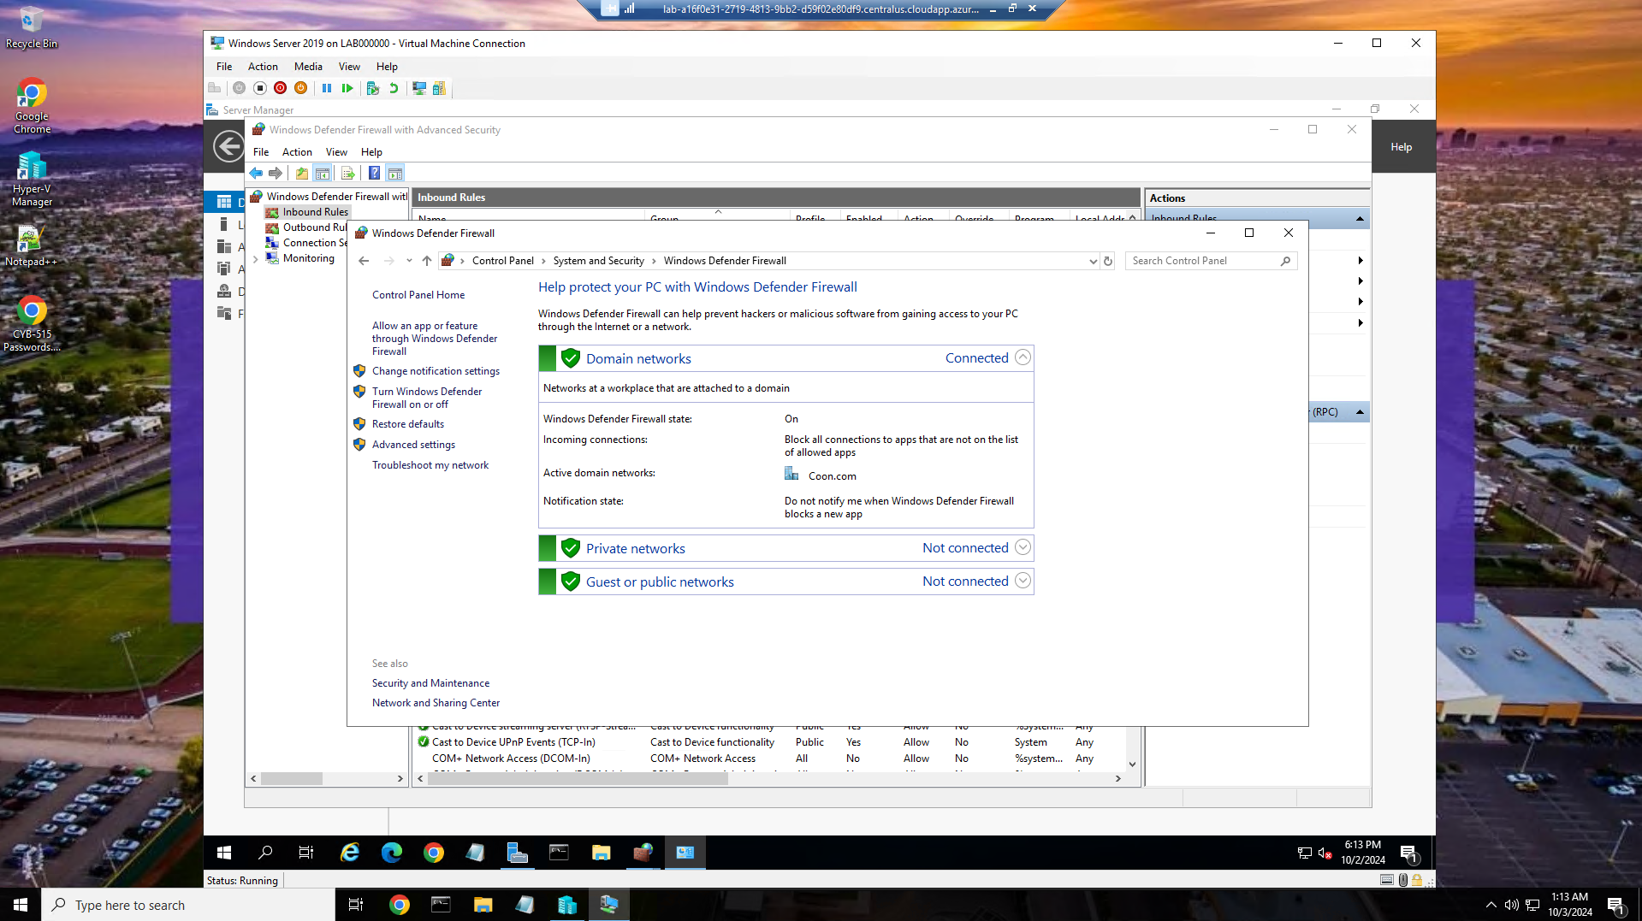

Checking the status of Windows Defender.

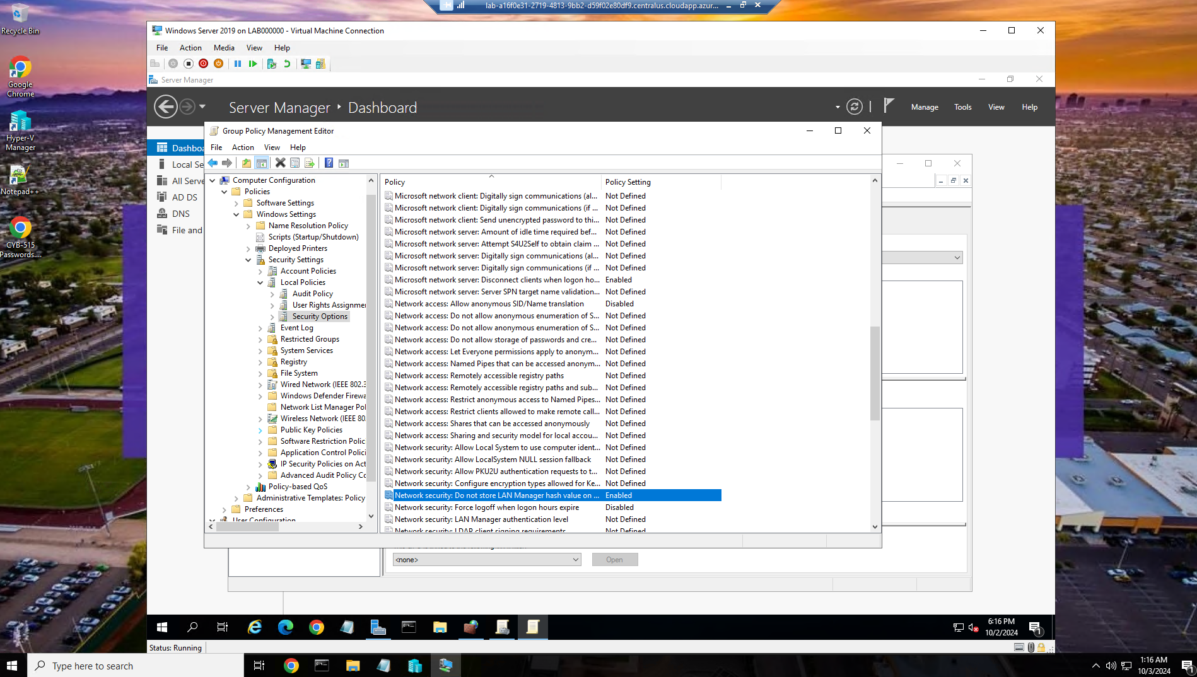

Don not store LAN Manager hash values enabled.

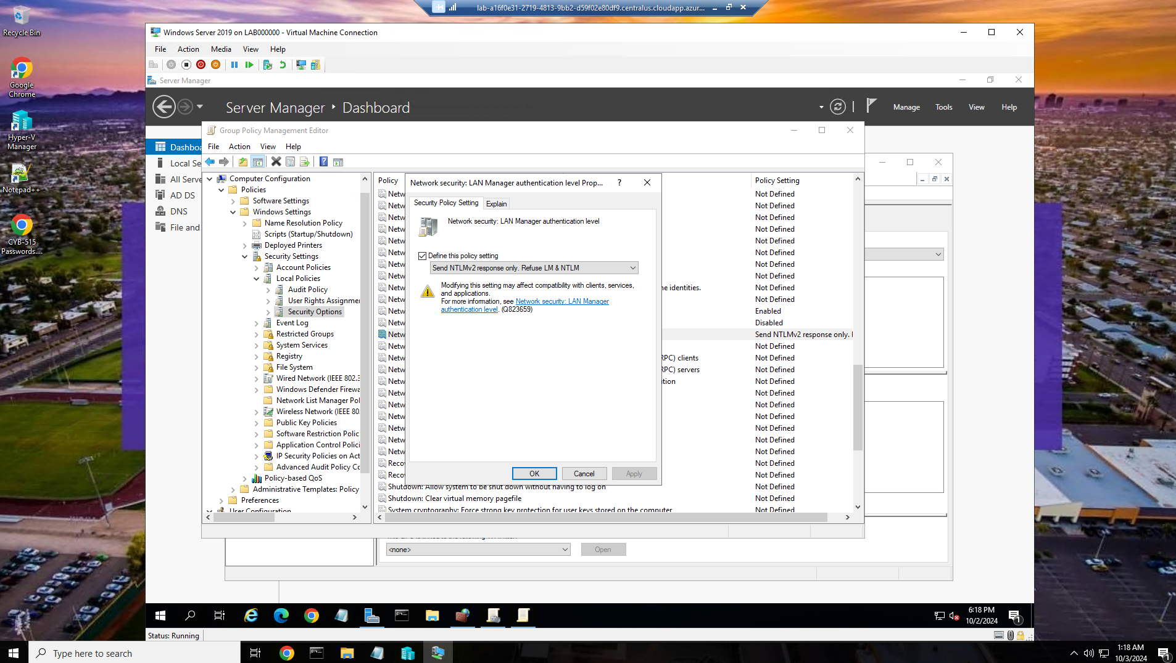

LAN Manager authentication level set to allow only NTLMv2 and refuse LM and NTLM

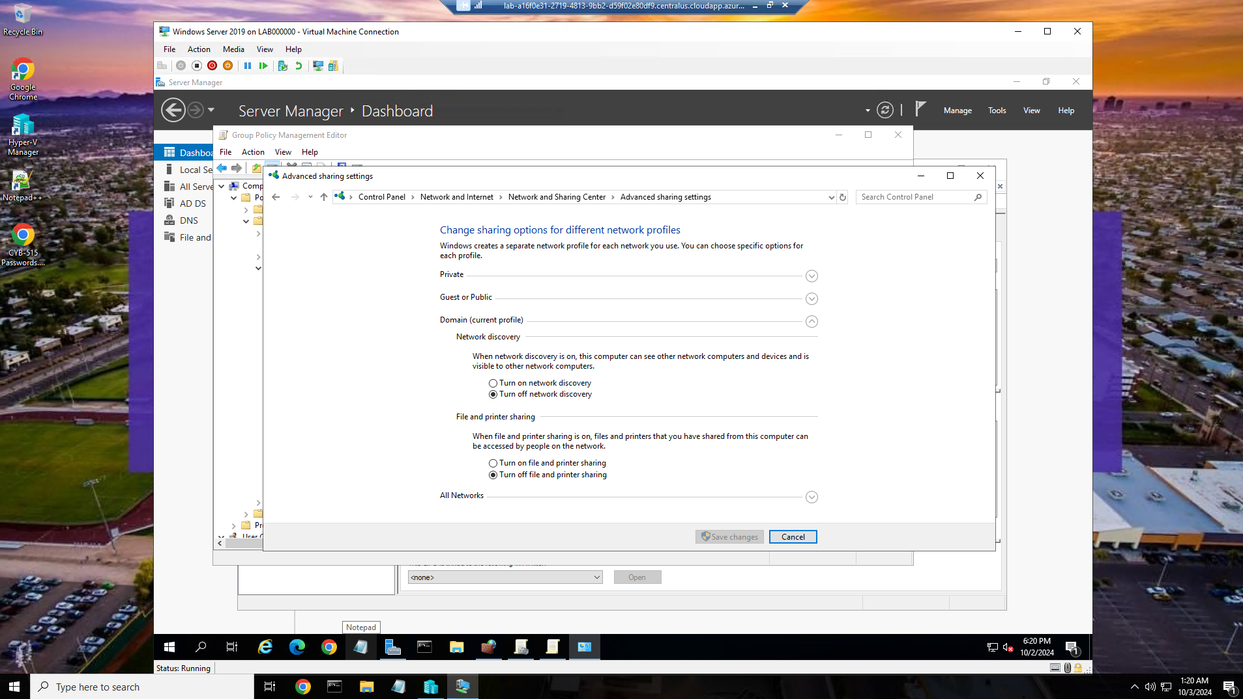

Removed file and print sharing.

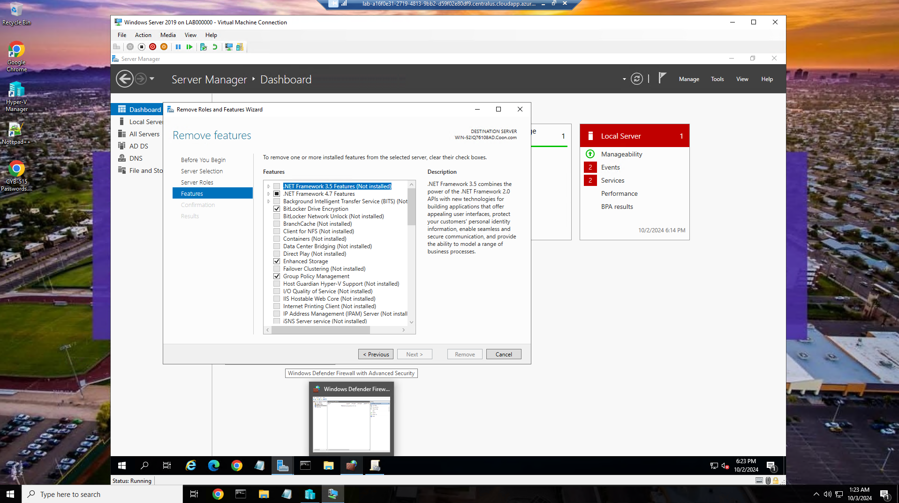

Removed unnecessary roles and features

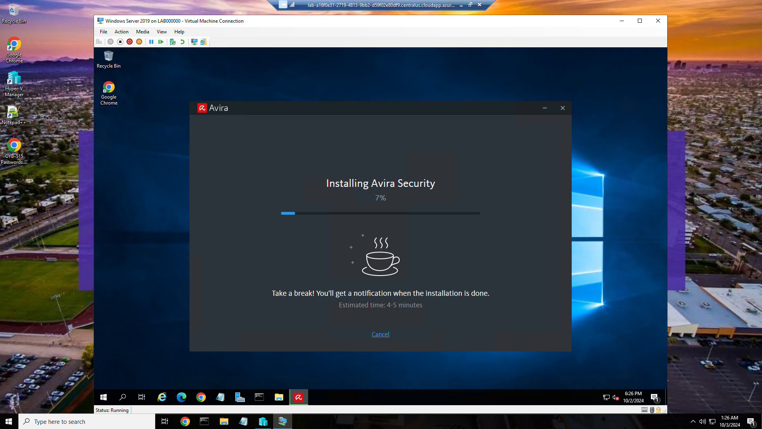

Installing Avira antivirus for windows servers.

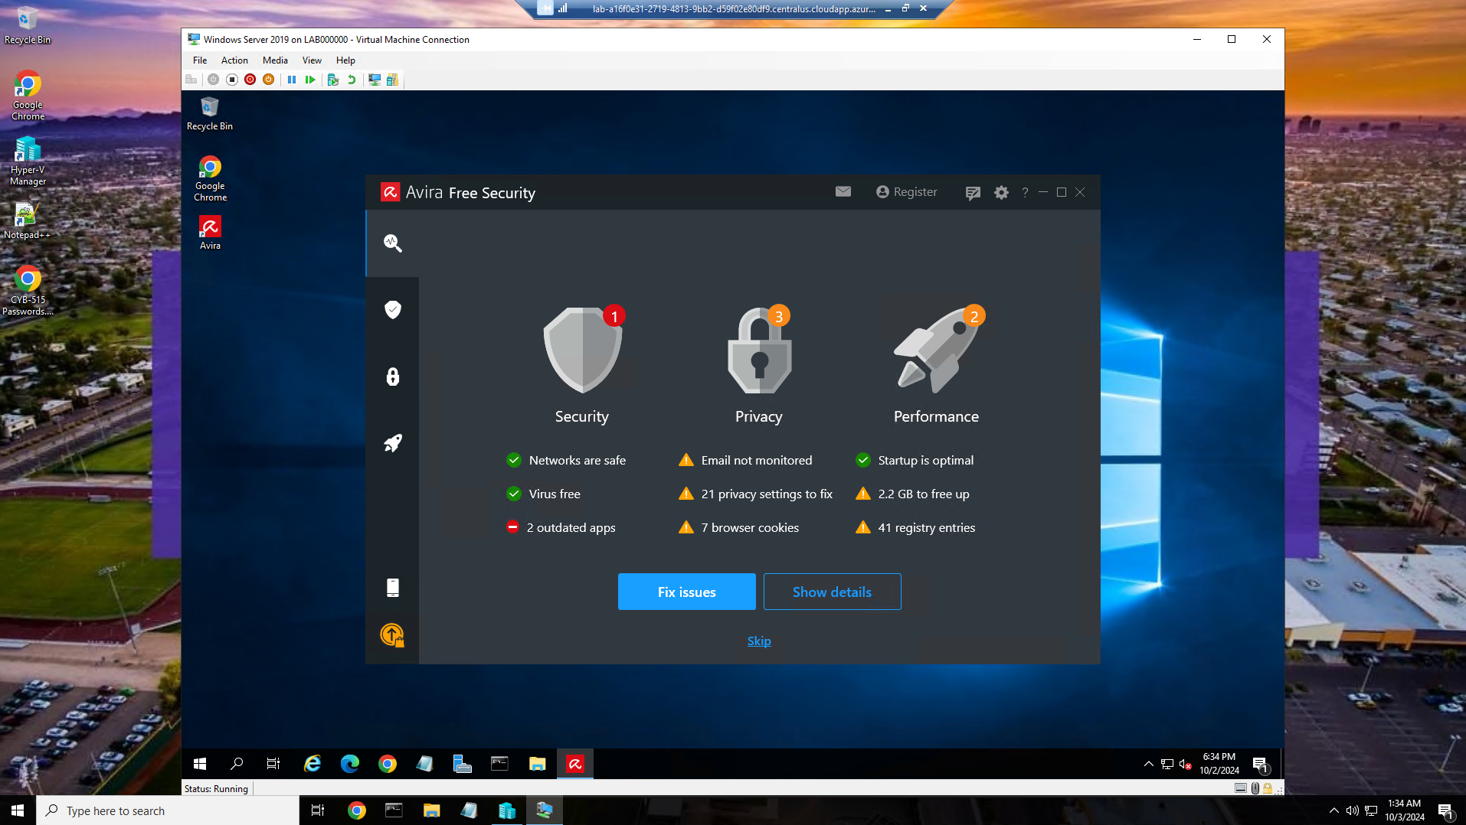

Here are the results of running a security scan with Avira.

Part 3:

Avira antivirus software has been found to have vulnerabilities, including a denial of service vulnerability in versions prior to 7.03.00.09(Rubenking, 2022). This vulnerability allows remote attackers to cause a denial of service (infinite loop and CPU consumption) via a malformed TAR archive. Avira's Vulnerability Detection Team has also identified critical vulnerabilities in late 2020. While Avira does not disclose the specific open-source components used in its software, it does state that its anti-malware SDKs are based on award-winning technology and deliver some of the lightest memory footprints, fastest start-up times, and best protection against malware.

Avira's security functions are designed to protect users from a variety of threats, including malware, phishing attacks, and data theft. The software includes real-time protection, a web protection feature that blocks access to malicious websites, and a microphone protection feature that controls which apps can access the user's microphone(Bleichert, 2024). Avira also offers a free VPN service that encrypts web traffic and prevents companies from collecting private data.

Avira's strengths include its comprehensive protection against a variety of threats, its user-friendly interface, and its low system footprint. However, Avira has been criticized for its performance, with some users reporting that the software can slow down their computers. Additionally, Avira's free version does not include all of the features of its paid versions, such as a password manager and a system optimization tool(Croft et al, 2022).

The requirements analysis necessary to formulate and deploy business information systems solutions within an organization is a critical step in the process. It involves identifying the needs and expectations of all stakeholders, including users, management, and IT staff. The analysis should also consider the organization's business goals, existing systems, and budget constraints. Once the requirements have been identified, they should be documented in a clear and concise manner. This documentation will serve as a guide for the development and deployment of the new system.

References:

Croft, P., Trejos, S., & McNally, C. (2022, November 4). *Avira Antivirus Review 2024: Pricey But Good*. All about Cookies. https://allaboutcookies.org/avira-antivirus-review

Janis von Bleichert. (2024). *Avira Antivirus Review: Still a Good Choice?* Experte.com; EXPERTE.com. https://www.experte.com/antivirus/avira

Karbauskas, Š. (2021, September 27). *Avira Antivirus Review (2021) How Good & Safe Is It?* CyberNews. https://cybernews.com/best-antivirus-software/avira-antivirus-review/

Rubenking, N. (2022, October 12). *Avira Free Security Review*. PCMAG. https://www.pcmag.com/reviews/avira-free-security-suite